Header
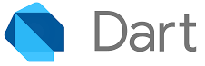
Flutter comprehensive training guide

Duration | 16 days
Total hours | 128 approx.
Prerequisities | Basic programming knowledge

Learning methodology

- The trainee shall prefer learning the topics from the provided sources instead of video guides to avoid `tutorial hell`.

- The trainee shall cover all the topics for a given day.

- The trainee may use AI tools to understand a topic but it's strictly prohibited for coding and problem solving.

- The trainee shall mandatorily practice typing for at least 2 hrs a day.

Key outcomes

- Strong `Dart` programming knowledge.

- Strong understanding of core programming principles such as OOP, SOLID etc.

- Strong understanding of rendering, layout and state management in `Flutter`.

- Strong understanding of `Domain Driven` architectural pattern.

Dart Training
Dart training
Mentor : Adarsh Sudarsanan

Day 01
Dart installation :
Download Flutter and add it to your system’s environment path. You shall be able to run flutter commands from the terminal.

Basics of Dart :
This provides a brief introduction to the Dart language through samples of its main features.
- How to define a variable in Dart? Ref
- What is null safety and how can we write null safe code in Dart? Ref
- What is the difference between a final and a const variable in Dart?
- What is operator precedence and how does it work in Dart? Ref
- What are the patterns available in Dart? Ref
- What are the operators available in Dart? Ref
- What are the built-in types in Dart? Ref
- What are `records` in Dart? Define a practical application of the same. Ref
- What are the collections available in Dart? Demonstrate how final vs const collections behave differently.
- What is a Generic in Dart? Define a practical application of the same. Ref
- What is a Typedef in Dart? Define a practical application for the same. Ref
- Explain how we can create an `Sound system` in Dart? Ref

Note: You shall create a code snippet briefing each of the above points.

Day 02
Control flow and functions in Dart :
Learn how to control the execution flow of Dart.
- How to create loops in Dart? Ref
- How to create branches in Dart? Ref
- How do we handle errors in Dart ? Ref
- How to create functions in Dart? Ref
- How to make Dart throw `StackOverflow` error? Can you create a system to avoid stackoverflows in Dart functions?
Note: You shall create a code snippet briefing each of the above points.

Exercise 1

/// Add a placeholder between elements of an array.
/// The placeholder shall not appear on the first and the last index.
/// You shall not create a new array.

Input: ["a", "b", "c"]
Required Output: ["a", "|", "b", "|", "c"]

Exercise 2

/// Find the Intersection of Two Lists.

Input: [1, 2, 3, 4], [3, 4, 5, 6]
Required Output: [3, 4]

Exercise 3

/// Rotate a List. Write a function to rotate a list to the right by K steps.

Input: [1, 2, 3, 4, 5], K = 2
Required Output: [4, 5, 1, 2, 3]

Exercise 4

/// Write a function to count the frequency of each character in a string.

Input: "banana"
Required Output: b: 1 a: 3 n: 2


Day 03
Object oriented programming :
Dart is an object-oriented language. Every object is an instance of a class, and all classes except Null descend from Object.

Follow the topics below in the given sequence to master Objects in Dart.
- What’s an Object? Ref
- How to create an object in Dart?
- What do you mean by creating an instance of an object?
- What is the difference between `value` and `reference` types? Ref
- What are enums in Dart and how do they differ from objects?
- What are the class modifiers available in Dart? Ref
- What is the difference between a final and a non-final property of an object?
- What are constructors available for an object in Dart? Ref
- How to create callable objects in Dart? Ref
- How can we extend properties of an object without modifying the object in Dart? Ref
- How can we achieve multiple inheritance in Dart? Ref
- Explain how mixins differ from objects in Dart.
- State the advantages and disadvantages of using a mixin over an object in Dart.

Exercise 1

/// Create practical classes in Dart using each one of the class modifiers.
/// Also provide your justification on why that modifier is used for the class.

/// For example...
/// Abstract class : Vehicle. It provides a common interface for all vehicles.
abstract class Vehicle {
void start();
void brake();
}

Exercise 2

/// Display how value vs reference type work in Dart using classes.
/// Create a method to break reference of a class.

Exercise 3

/// Create two classes in Dart such that one has constant instance and the other does not.
/// Modify the classes created in 1.0 to include sensible constructors to them. Try to cover all the availble constructors.

Exercise 4

/// Create a practical example showcasing the use of mixin in Dart development.


Day 04
Async programming : Futures
Learn the following topics thoroughly since this is the most important factor in defining the performance of an application.
- What is a `Future` in Dart? Ref
- What if you’re looping through a large dataset (ideally this shouldn’t happen) and you want to perform some operation after the loop is completed.
But loops aren’t asynchronous in Dart. So how can we create our own Futures in Dart? Ref
- How to handle the results of a Future? Compare between the chaining operation .then() vs async-await.
- How can we create our own chaining operations for a Future?
- What is Future composition in Dart? Explain the difference between Future.wait() and Future.any().
- Explore the `Timer` class in Dart.
Note: You shall create a code snippet briefing each of the above points.

Exercise 1

/// Create a DeBounced search in Dart.
/// Expect character inputs from the user, run de-bounced search for each character in a static array.

Dataset: ["John", "Michael", "Sarah", "Emma", "Daniel", "Sophia", "Matthew", "Olivia", "James", "Emily"]

Exercise 2

/// Create a parallel search from two different datasets.
/// Expect character inputs from the user, run parallel search

Dataset 1: ["John", "Michael", "Sarah", "Emma", "Daniel", "Sophia", "Matthew", "Olivia", "James", "Emily"]

Dataset 2: ["David", "Emma", "Sophia", "Michael", "Liam", "Olivia", "Noah", "Isabella", "James", "Ava"]

Exercise 3

/// Create a function that timesout if the operation doesn't finish within a given time duration.

/// Example:
void asyncOperation(final Duration duration) async {
// ..some heavy operation
// TODO: stop the operation and return after the [duration].
}



Day 05
Async programming : Streams
Learn the following topics thoroughly for implementing reactive programming.
- What is a `Stream` in Dart? Ref, How to create your own Stream in Dart?
- How can a stream be modified? Explain with practical examples. Ref
- How can a stream be transformed? Explain with practical examples. Ref
- How to get the values of a Stream?
- State the difference between single subscription and broadcast streams.
- How to use StreamController, StreamBroadcast and StreamSubscription.
Note: You shall create a code snippet briefing each of the above points.

Exercise 1

/// Create a timer.
/// Expect required time in seconds from the user.

Exercise 2

/// Combine two streams.
/// The streams should emit odd and even number respectively.

Exercise 3

/// Create a de-bounce search based on stream.
/// Listen to a simulated text input. Implement a debounce mechanism that waits for a short period (e.g., 300ms) after the last character is typed, and then triggers a function to process the final input.


Flutter Training
Flutter training
Mentor : Adarsh Sudarsanan

Day 06
Flutter setup :
Install Android Studio/ VsCode for Flutter development. The former is preferred due to its superior mobile development support tools.
Don’t enable any AI based code copilot.
- Create your first flutter project.
- Explain in brief the use of organization identifiers. Eg., com.example
- Add extensions for Flutter, Dart and BLOC. You can also install additional extensions for theming of your preference. Don’t bloat your IDE with unnecessary extensions.
- Run your project in both an android/ iOS simulator and an actual android/ iOS device.
Learn all the shortcuts for the IDE of your choice. The following actions shall only be performed using shortcuts:
- Run/ Debug a project.
- Re-Format the code.
- Creation of constructors, getters and setters.
- Implementation of code hints.
Erase all the skeleton Flutter code from the newly created project.
- Create a void main() function in the main.dart file. Add documentation comments above the function explaining the use of the function in Flutter.
- Create a new dart file named app.dart. Create a StatelessWidget named App in the file. You can type `stless` and auto create the widget if you’ve the extensions mentioned above installed.
- Modify the main.dart file as follows :

void main() {
runApp(App());
}

Learn the following topics in sequence to understand what we’ve developed so far.
- What is a Widget in Flutter? Ref
- What is Widget composition in Flutter? Ref
- What is a Widget State in Flutter? Ref
- How can we update a Widget State in Flutter? Hint: setState

Exercise 1

/// Create a new dart file in the current project. Create a Stateful Widget. Modify your app.dart as follows.

import "package:flutter/material.dart";

class App extends StatelessWidget {
const App({super.key});

@override
Widget build(final BuildContext context) {
return MaterialApp(home: YourStatefulWidget());
}
}

// Modify your stateful widget to have a button and a text indicating how many cdtimes the button has been tapped.

- What is Scaffold? Observe how Flutter behaves differently with and without the use of Scaffold.
- What is MaterialApp? Observe how Flutter behaves differently with and without the use of MaterialApp.
- Create an example using all of the below predefined Widgets
  - Container, Column, Row
  - Text, Button (Filled, Outlined etc)
  - Scaffold, SafeArea, AppBar, FloatingActionButton
- Explain Widget Lifecycle and Widget Tree in Flutter. Ref

Day 07
Layout :
Explore how Layouts and Constraints work in Flutter.
Learning outcomes from the resources :
- Main and cross axis alignment in Row and Column.

Sizing widgets within rows and columns.
- Adaptive Layout using LayoutBuilder.
- Scrollable builders.
- Strong understanding of the phrase “constraints go down, sizes go up and parent sets position”.
Create your own version of the 29 examples given in the constraint source.

Note: Don’t skip through any content from the sources. Strong understanding of layouts and constraints are required to avoid UI related bugs in application development.

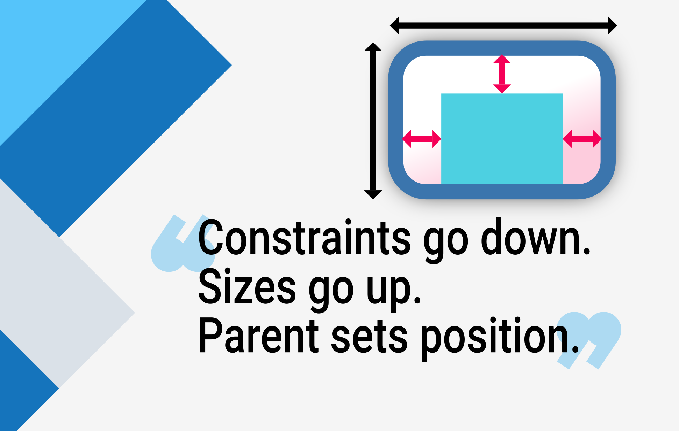

Day 08
UI Development :
Develop the following UI using the Widget you’ve learned until now.

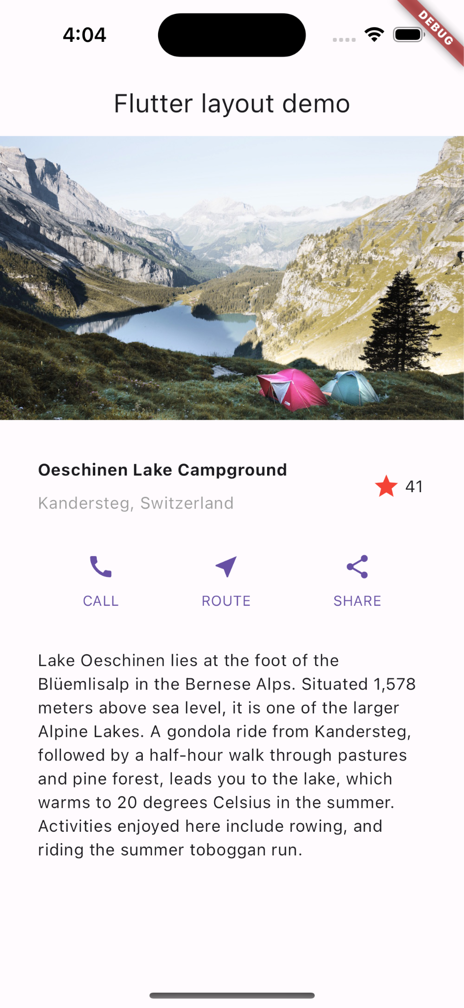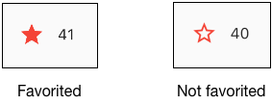

Refer to this source only after you’ve developed the above UI. The source contains the ideal way of creating it.

Explore the following topics in sequence to make the UI you’ve created responsive across platforms.
- Adaptive and responsive design in Flutter. Ref
- Modify your UI to look good on all of the platforms by
  - Replace all the material buttons to cupertino buttons when the platform is iOS.
  - Replace the Scaffold to CupertinoScaffold when the platform is iOS.
  - Modify the layout to look good in larger and wider screens for when the platform is web, windows or iOS.
  - Add haptic feedback for button taps.

Day 09
Theming :
You would’ve noticed that the last UI you’ve created has a default design but what if we’ve to develop some more complex UI like the following

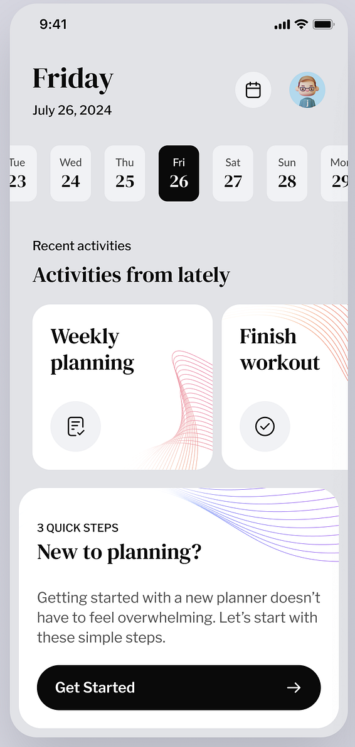 Note: Ignore the stripes on the Cards.lief

Before developing such UIs we shall understand themes in Flutter. Ref
- Create your own theme class in Flutter.
- Develop the above UI without using colors or styles manually, you shall import all the required colors and styles from Theme.of(context) only.

Day 10 - Day 11
State management in Flutter :
- Explain why state management is required in Flutter?
- Explain the disadvantages of setState.
- Explore Provider and create an example using it.
- Explore StatefulBuilder and create an example using it.
- Explain the shortcomings of both Provider and StatefulBuilder.

BLOC :
- Explain the requirement of BLOC in Flutter development.
- Learn how to create BLOC and CUBITS. Ref
- Explain the difference between BLOC and CUBIT.

Note: Update the UI you’ve developed in Day 10 and implement dynamic theming feature using CUBIT.

More resources for BLOC
- Flutter Bloc EASY Tutorial
- The Best Flutter Bloc Complete Course - Visualise, Understand, Learn & Practice Bloc Concepts

Create your own BLOC using streams in Flutter.

Day 12 - Day 13
TDD and Domain Driven development in Flutter :
Domain-Driven Design (DDD) is a software development methodology that focuses on modeling software to match a business domain, or the specific context in which the software operates.

Sources to learn DDD and TDD.
- Flutter TDD Clean Architecture Course [1] – Explanation & Project Structure
- DDD
- Working Demo

TDD and Domain Driven development in Flutter :
Learning how to communicate with services in Flutter. Ref
- Explore the dio package.
- Explore the http package.
- Create a base network class that can handle multiple network requests using the http package.

Day 14 - Day 15
Develop a complete sample app.
Develop a todo list application.
- You can develop the UI on your own but it should be both consistent and appealing.
- The design should be responsive.
- Follow both TDD and DDD during development. The code will be reviewed, so make sure you follow all the optimal practices.

Day 16
GIT and application stores :
- Learn about how the company implements CI/CD for flutter projects in both android and iOS.
- Learn the basics of git.
- Add company gitlab to your IDE.

AppStore and PlayStore :
- Learn how to create release builds of Android and iOS.
- Learn the account creation and app upload process for each of the stores.

